Name: G. Bhuvana Chandrika

Trainee name: Harshee Pitroda.mam

Course name: Python & Machine Learning Basics

Date:30/May/2022

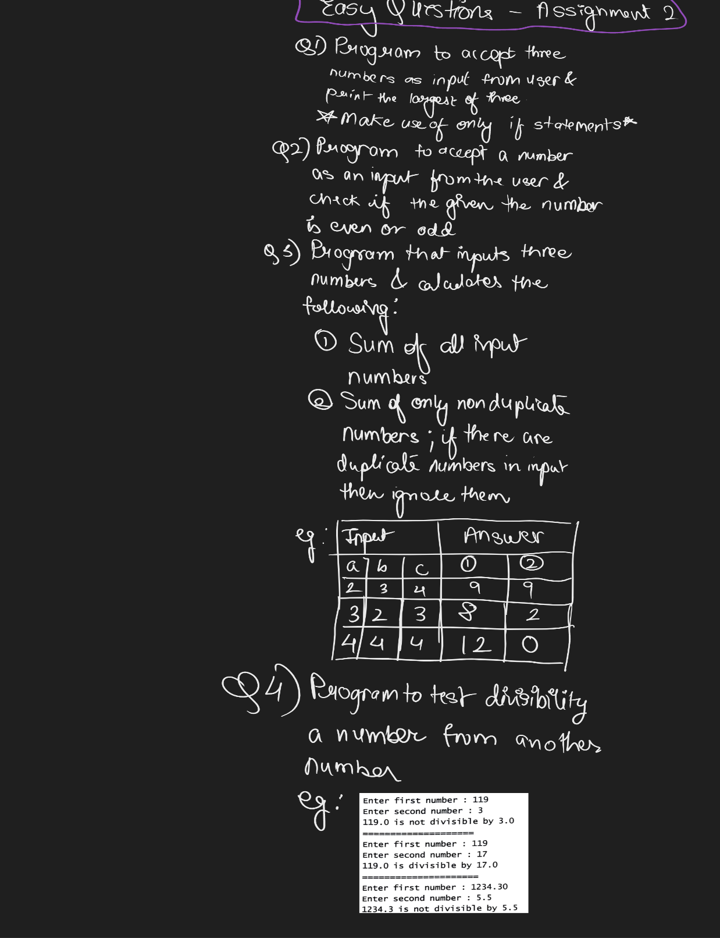

1)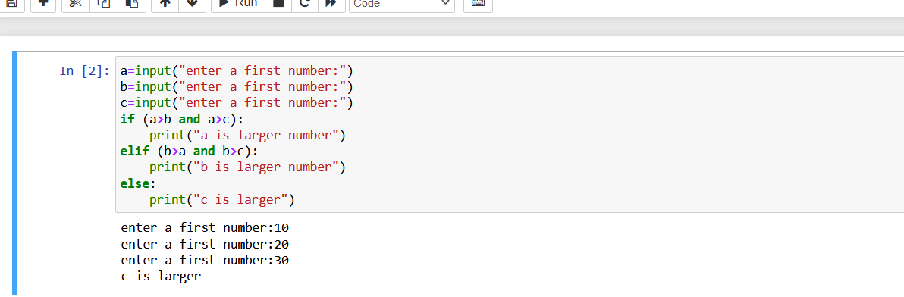

2) 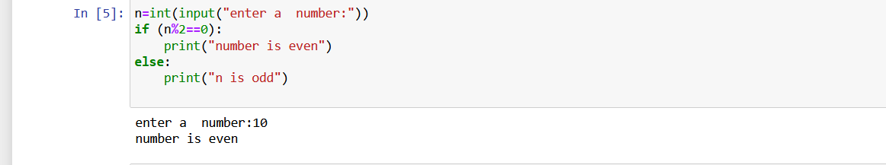

3) 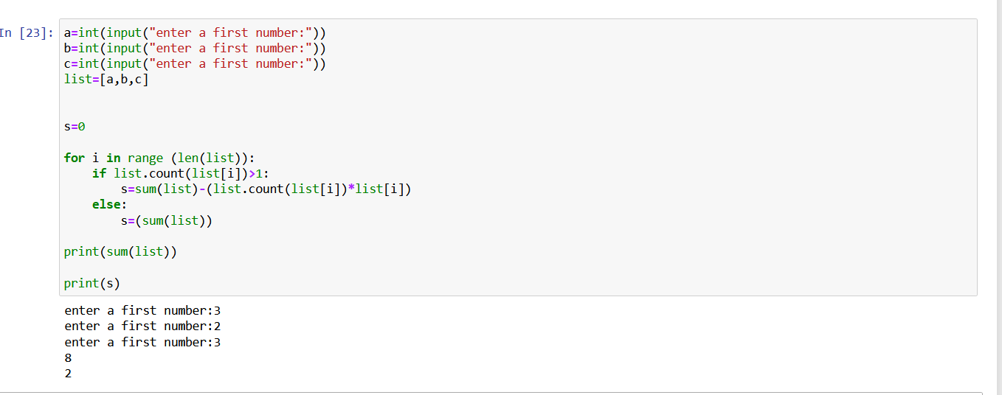

4) 